ASSIGNMENT 1

TOPIC : SERVER MOTOR ROTATION

// C++ code

**//**

**#include<servo.h>**

**servo s;**

**void setup()**

**{**

**s.attach(3);**

**}**

**void loop()**

**{**

**s.write(0);**

**delay(1000);**

**s.write(30);**

**delay(1000);**

**s.write(60);**

**delay(1000);**

**s.write(100);**

**delay(1000);**

**s.write(130);**

**delay(1000);**

**s.write(180);**

**delay(1000);**

**}**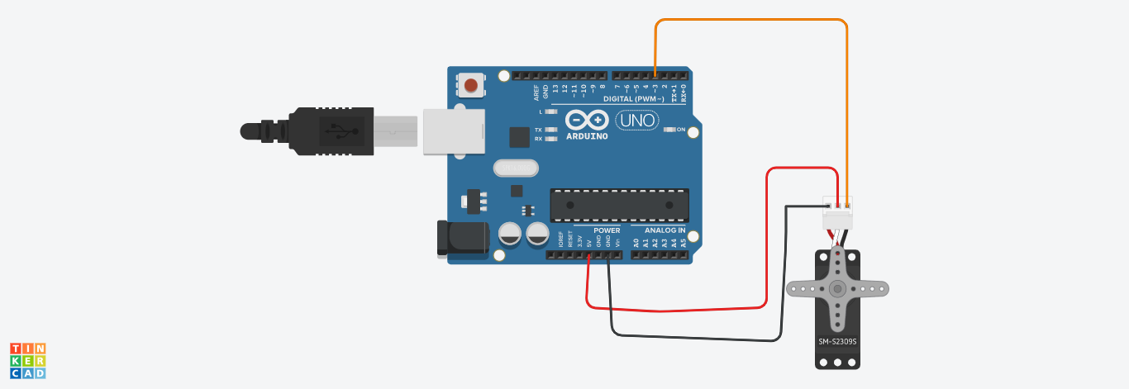

**BY**

**S.VISHNUPRIYA**

**2019PECEC228**

**211419106297**